AMERICAN CHESTNUT RESTORATION PLAN

“Our overarching goal is to position American chestnut to reoccupy its native range.”

INTRODUCTION
This “tactical” restoration plan is intended to reflect the best thinking of the TACF chapters with input from our scientists. The plan is designed to give maximum flexibility to the chapters to try a variety of restoration techniques. This is critically important since American chestnut was decimated before much was learned about its silviculture. The plan should be considered as a business plan or operating plan to successfully complete the second half of our mission, restoring blight-resistant trees to their original habitat.

Natural History, Distribution, and Habitat Requirements
American chestnut was formerly a tree of great economical, ecological, and sociological importance. Numbering approximately 4 billion, American chestnut encompassed approximately 25% of the canopy throughout much of its range, covering approximately 200 million acres (see Fig.4). It was a broad generalist in terms of its soil requirements, but seemed to prefer rich, well-drained, slightly acidic soils. American chestnut formerly dominated ridgetops where disturbance was great and its sprouts could out-compete others, often forming pure or nearly pure stands up to 100 acres in size, and could be found at elevations from 500-5000 feet above sea level.
These fast-growing trees could live approximately 600 years and attain diameters greater than 10 feet and heights greater than 100 feet. American chestnuts grow tall and straight, yielding wood that is rot-resistant, strong, lightweight, and easily worked, making the timber quite valuable. Its wood was commonly used for railroad ties, building construction, telegraph poles, and fencing. The bark was a great source of tannins, which were also of value and were extracted and used in leather processing.
The reliable, abundant nut crop served as a source of nutrition for many small mammals, deer, bears, turkey, song birds, livestock, and people. Chestnut harvests of yesteryear had a way of bringing people and communities together. Not only would people come together for collection, but also for consumption. Children and adults would gather nuts from the forest and either sell them at the local market or store them for eating through the winter months. Entire railroad cars filled with nuts were shipped to cities and sold in stores and freshly roasted in the streets. Hog farmers would turn loose their hogs into the woods to fatten on the chestnut crop before they were slaughtered, which not only increased their weight, but also lent the pork a sweeter flavor. American chestnut flowers in June and July, enabling it to escape the ravages of late spring frost, ensuring a reliable nut crop. It was by far the largest mast producer within its range and affected the region’s carrying capacity for species far beyond those which directly consumed the nuts.
Cryphonectria parasitica, a fungal pathogen of Asiatic origin, was imported into the United States in the early 1900’s with the introduction of exotic chestnut nursery stocks. The disease was first reported in New York City in 1904 and within 50 years, the fungal blight had spread throughout the majority of the chestnut’s natural range causing the ecological extinction of American chestnut. Many efforts were attempted to contain and halt the spread of the blight, but those efforts were futile. The fungus was disseminated by wind, insects, and animals, including humans. Cryphonectria parasitica is an ascomycete fungus that infects the American chestnut through wounds and furrows of the bark. The pathogen then grows in the bark, forming mycelial fans which infect healthy tissues. The fungus then attacks the phloem, vascular cambium, and xylem, effectively girdling the tree, but leaving the root system alive.
Today, natural regeneration of American chestnut through sexual reproduction is an extremely rare occurrence, as they do not self-pollinate and finding two flowering trees in close proximity is uncommon. Fortunately, chestnuts have the capacity to produce stool sprouts (stump sprouts) which was noted in early literature because of the potential for management of chestnut forests through coppicing. This ability to sprout has retained American chestnut’s presence in eastern forests, but what was once a dominant overstory tree has been reduced an occasional understory shrub.
Chestnut blight was not the first exotic fungal pathogen to strike American chestnut. Phytophthora cinnamomi, a soil borne pathogen that destroys root systems, was imported into the piedmont areas of the eastern U.S. prior to the Civil War. American chestnut, which formally grew in heavily clay soils of the piedmont, was eliminated here. If current efforts by TACF lead to a solution to this problem, the restoration effort will be greatly expanded. Phytophthora cinnamomi is a major impediment to restoration efforts over much of the historical range.

The American Chestnut Foundation
Since 1983, The American Chestnut Foundation (TACF) has been selectively breeding the few surviving American chestnuts that produce flowers with Chinese chestnuts (Castanea mollissima), with the hope of one day restoring this venerable tree throughout its native range. By crossing the surviving American chestnuts with Chinese chestnuts and back-crossing the offspring with different American chestnuts three times, TACF has produced backcross chestnuts that are essentially 15/16 American chestnut in character and 1/16 Chinese chestnut in character (Fig. 5). At each step in the back-cross procedure, the hybrids were tested for blight resistance. Only trees with a high blight resistance were used in successive breeding stages. Backcross trees with strong blight resistance that are 15/16 American chestnut in character will then be intercrossed with other 15/16 American trees twice (again, resistance is tested at this step), to ensure a high level of homozygosity at the blight resistance loci in the final product (i.e. the B₃F₃ generation). The ultimate goal of TACF’s breeding strategy is to breed all of the Chinese characteristics out of the advanced hybrids while retaining the blight resistance possessed by Chinese chestnuts, in effect, producing trees that are true-breeding for blight resistance and essentially American chestnut in all other characteristics. TACF has been producing their first B₃F₃ trees for several years, and began progeny testing plantings in 2009. TACF expects the 15/16 B₃F₃ generation to be the first generation suitable for widespread distribution, but plans to continue breeding disease resistant backcross lines. Most of the focus of the breeding program will be to incorporate additional resistance sources into our Restoration Chestnuts.

THE RESTORATION CONCEPT
The sheer magnitude of re-establishing chestnut across 200 million acres by means of a concerted investment in planting or seeding seems utterly infeasible. However, it does appear possible to advance the restoration effort through planned, carefully dispersed plantings with the expectation that restoration will eventually be completed over the course of decades through a combination of fill-in plantings and the naturalization of planted populations.
Several types of plantings fall under the broad umbrella of restoration. Some of these are:
- Progeny test plantings following the existing testing protocol. There is a need to expand this testing, and some of our earliest work will be in this category.
- Restoration plantings in pure stands or mixed with other species to test the long-term competitiveness of our Restoration Chestnuts. These will eventually include both the Clapper and Graves lines on the same site, generally on one to three acres. A protocol is included in this plan.
- Demonstration plantings to provide public outreach and education.
- Common garden tests—multiple seed sources grown in one location.
- Provenance tests—single seed sources grown in multiple locations.
- Silvicultural tests to determine which cultural practices and planting techniques work best. This could also include testing how Restoration Chestnuts compete with historical cohorts.
The areas initially set up as testing or demonstration plantings, if successful, will become the first restoration plantings of American chestnut. Only after TACF can document that the Restoration Chestnuts have the appropriate level of blight resistance and American growth characteristics can the planting be considered a restoration planting.
However, waiting until we have all the answers would delay restoration for decades. There is the risk that some plantings will fail or prove less than acceptable. In these cases, it may be appropriate to replace the existing trees with more suitable materials as our breeding program continues to advance. Another option may be to do additional plantings in close proximity to the original one. Natural selection will, over time, select for the trees that exhibit the appropriate levels of fitness.
The most logical approach to restoration is to systematically divide the range into manageable cells. This is accomplished by establishing a grid system that covers the original range with grid cells based on USGS 1:24,000 (7.5 minute) topographic quadrangles. Each 7.5 minute quad is approximately 58 square miles or 37,120 acres in size. Within the original range of American chestnut, there are about 5400 7.5 minute quads. Using 7.5 minute quads (“cells”) as the basic unit for restoration activity permits local planning and action through volunteer efforts, but within the context of a national strategy and centralized database.
Eventually, chapters will establish at least one seminal planting in each of the cells containing suitable habitat. However, for the first ten to fifteen years, Phase I of our restoration work, a lesser number of our restoration cells will be attempted—perhaps half of the 5400. The actual number will be a product of chapter input and will reflect the capability of the chapter and their willingness to use Meadowview seed.
In many areas, it will make sense to lump two to four cells together, for example within a drainage. If cells are grouped together, we should still disperse our seminal plantings over the entire range.
It may happen that a second or third planting will occur in some cells before the seminal planting is done in others, but one planting per habitable cell will be the initial goal. Some cells will contain few, if any, suitable reintroduction sites—i.e. little or no forested lands. Such cells would have low priority for restoration plantings. It is also critical that some large areas within the original range remain unplanted for long-term monitoring purposes. Some national parks, such as the Great Smoky Mountains and Shenandoah National Park would logically fill this need. Wilderness areas on national forest land would also qualify. The location and spacing of plantings within cells must be flexible since we have to find landowners who are willing to grow our chestnut trees for several decades.
A critical component of the concept is the recruitment of Restoration Branches, community volunteers who become TACF members and serve as arms of our chapters to oversee cell restoration. (see Appendix A for information on how to make this happen.) Restoration Branches will play a role both in financing the restoration effort and in actually doing the field work. Since individual Restoration Branches will be responsible for numerous plantings, additional field volunteers will be required. These volunteers, Chestnut Stewards, will work closely with Restoration Branches to perform a variety of tasks, including planting, clearing competing vegetation, installing solar-powered deer fencing (if required), fertilizing (if required), annual measuring, and other data collection responsibilities. These additional volunteers can be recruited from sportsmen clubs, church and civic clubs, Boy Scouts, community members, Master Gardeners, and Master Naturalists. The Chestnut Stewards would work very closely with both the state chapters and the hosting landowners.
It is very important that young people be heavily represented and given meaningful tasks in caring for the plantings. These are the people who will be around to see the restoration of chestnut completed.
When trees in seminal plantings begin producing chestnuts, the Chestnut Stewards will be asked to harvest, when practical, as many of these nuts as possible and use them to establish additional plantings within the same cell. These additional plantings also would involve a willing landowner and would be installed under the direction of the state chapter. Although re-establishing American chestnut will eventually furnish a much needed source of nutrition for wildlife, these first nuts are most needed for additional plantings.
The concept is predicated on the demonstrated ability of American chestnut to expand on its own, once established in the main canopy and surrounded by forests that are frequently disturbed. The effort of cooperating landowners and the volunteer groups should promote rapid nut production if proper cultural care is provided, and the use of these nuts to establish additional plantings in the same cell will greatly accelerate the reintroduction effort. It should also be noted that most of the forested acres within the original range of American chestnut will be disturbed frequently during coming decades whether by logging, natural disturbances, or impacts of exotic insects or diseases, and these disturbances will provide opportunities for chestnut expansion.

ADAPTIVE MANAGEMENT
This restoration plan recognizes significant data gaps and significant ecological uncertainty. Ecological uncertainty should not be used as an excuse for inaction but instead as a realization of the need to use the “adaptive management” process in restoring the American chestnut. Adaptive management is a decision process that promotes flexible decision making that can be adjusted in the face of uncertainties as outcomes from management actions and other events become better understood. Careful monitoring of these outcomes both advances scientific understanding and helps adjust policies or operations as part of an iterative learning process. Adaptive management also recognizes the importance of natural variability in contributing to ecological resilience and productivity. Adaptive management does not represent an end in itself, but rather a means to more effective decisions and enhanced benefits. Its true measure is in how well it helps meet environmental, social, and economic goals, increases scientific knowledge, and reduces tensions among stakeholders.
The sequence of activities shown in Fig. 1 is often used to characterize adaptive management. Chapter or stakeholder involvement should be used throughout sequence. Additional structure can be incorporated into this sequence, by recognizing an embedded feedback loop of monitoring, evaluation, and management adjustments that focuses specifically on learning about the impacts of management. Multiple iterations of this loop may occur within each iteration of the overall cycle, accelerating learning about ecological process within the more comprehensive cycle that includes learning about the adaptive process itself (through periodic problem reassessment, design, and implementation).

Fig. 1--Adaptive Management Process

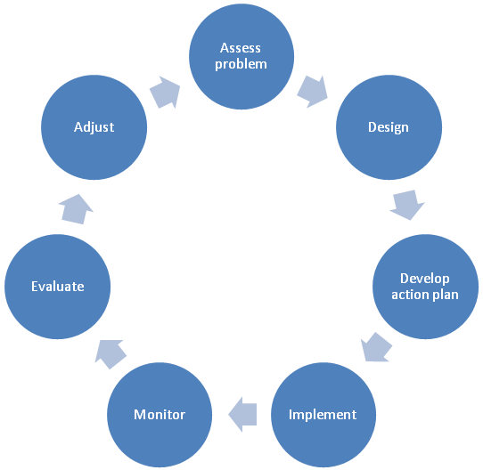

Every five years, or at shorter intervals, if monitoring results indicate a need, a formal evaluation will be conducted to determine if the restoration plan needs adjustment. This evaluation will be conducted by TACF scientists and the restoration steering committee.
ROLE OF THE NATIONAL OFFICE
As additional seed comes on line from various chapters, the overall program management could become quite complex. There are several options available to TACF to better orchestrate the long-term distribution of seed. The most straight-forward approach to managing the collection, growing, and distribution is to use the TACF national headquarters as a clearing house. This program management would be done in accordance with a plan established and approved by the state chapters. TACF headquarters would:
- Develop contracts with state nurseries to grow seedlings (with chapter input)
- Work with state nurseries to develop pricing for growing and distribution
- Manage database to track annual inventory of seed
- Manage database of seed requests received through the state chapters
- Coordinate with state chapters on the allocation of seed within their state
Manage shipping and delivery of seed to either the state or the appropriate local representative

Continuation of Breeding Program
It is important to note that the breeding program of TACF will continue with additional backcrossing done as needed. Our goal is to capture the Chinese genes that confer resistance but as few other Chinese genes as possible. However, the most important aspect of continued breeding will be to incorporate additional sources of resistance into the Restoration Chestnut. As better performing or more resistant material becomes available, it will be incorporated into the restoration effort.

RESTORATION PHASES
There will be two phases of the restoration effort:
Phase I will be establishing at least one planting in as many of the 5400 restoration cells as we determine is feasible. This number will likely be 2,700 to 3,000 cells. Our goal will be to accomplish this within 10 to 15 years. Where it is logical, several cells will be aggregated for the purpose of developing locally adapted land races. In these aggregated cells, nuts from the first or “seminal” planting will be collected and used to establish additional plantings within the same cells. However, even in these areas, as chapter seed or better performing Meadowview seed becomes available, they will be used to augment or even replace existing material.
Phase II of restoration will begin after chapter orchards come on line, 10 to 15 years from now, and enough seed is available to allow widespread distribution to the public. This assumes that testing results assure us the material is good enough for restoration.
Implementing Phase I
The first B₃F₃ nuts will come from our research farms at Meadowview Virginia. By 2012, we are projecting a harvest of more than 44,000 nuts. The Pennsylvania chapter will likely produce a similar number by 2015.
Figures 2 and 3 display the range of American chestnut by counties within concentric circles of Meadowview and Pennsylvania, increasing by 100 mile intervals. Tables 1 and 2 project harvest of Clapper and Graves’ B₃F₃ from Meadowview and Pennsylvania. Most of the range south of the Pennsylvania state line falls within 300 miles of Meadowview, and most of the northern part of the range is within 300 miles of Pennsylvania.
Phase I of the restoration effort will utilize Meadowview seed south of the Pennsylvania state line and possibly Pennsylvania seed in much of the northern portion of the range. Tables 1 and 2 give a possible schedule by states for populating cells based on availability of seed from Meadowview and Pennsylvania.
Southern cells of Ohio and West Virginia will be planted with Meadowview seed while the northern portions of both states will utilize Pennsylvania seed. Mississippi restoration must wait until we have a chapter formed in the state. For the few years before Pennsylvania seed comes on line, states in the northern portion of the range could plant small amounts of Meadowview seed, if they choose to do so.
The initial seed from Meadowview will be Clapper only. When the Grave orchard comes on line, each restoration cell of approximately 3 acres will be planted with 700 Clapper seed and 700 Graves seed. Allowing for mortality and thinning, we need 100 trees per acre free to grow into the main canopy with adequate space for crown development, on the three or more acres of restoration planting. One hundred trees per acre assumes a pure stand of chestnut. More than three acres should be planted if a mixed stand is desired.
Phase I of the restoration effort, populating the cells, positions Castanea dentate for success. Over a long time period, Restoration Chestnut will likely spread from these seminal plantings to reoccupy its original range. We will hasten this with Phase II of the restoration effort-- releasing advanced seed to the public.
The basis for the projections is our estimate that we need to plant 700 seedlings per cell. After mortality and thinning, we're hoping 300 trees remain, spread over three acres. Three hundred trees is computed from the relation, "Desired #B₃-F₃s = 15 * #B3 lines. Having 15 B₃-F₃s for each B₃ line keeps the effective population size within 95% of the size when the number of B₃-F₃s and B₃-F₄s is arbitrarily large. Effective population size was computed as the harmonic mean of the numbers of B3 lines, B₃-F₂s, B₃-F₃s and B₃-F₄s.
We currently are planning on obtaining:
- Twenty B₃ lines, which would capture any alleles present at frequencies greater than 5% in the collection locale (5% = 1/20).
- Nine B₃-F₂ progeny for each line. These 9 progeny would capture more than 95% of the alleles present in a single B₃ parent.
- Fifteen B₃-F₃ progeny for each line. These 15 progeny would retain 95% of the genetic diversity, as measured by a decrease in the effective population size from an effectively infinite number of B₃-F₃s and B₃-F₄s.
- We arbitrarily assumed that 10,000 B₃-F₄s would be produced by the B₃s. As long as this number is large, it does not affect the harmonic mean.
The density of 100 trees per acre remaining for trees at maturity is designed to ensure abundant nut cropping, with little inter-tree competition. This is assuming a pure stand of chestnut would remain. More than three acres would need to be planted if a mixed stand were desired.
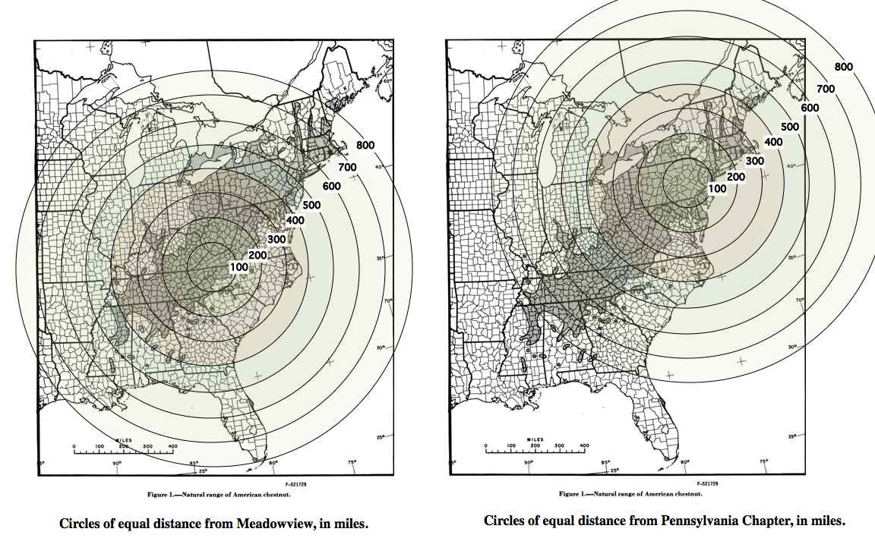
Fig. 2 & 3—Distances from Meadowview and Pennsylvania Chapter, in miles

Table A.—Number of Restoration Cells per state by year for Pennsylvania Chapter Nuts
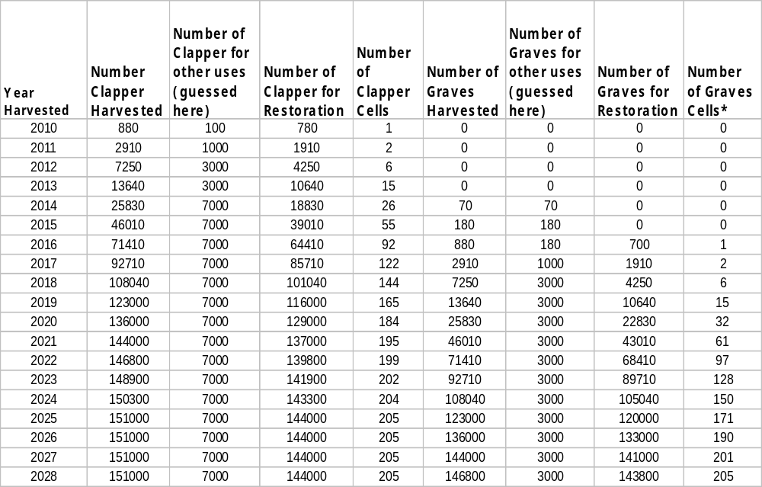

Table B—Number of Restoration Cells per state by year for Meadowview nuts

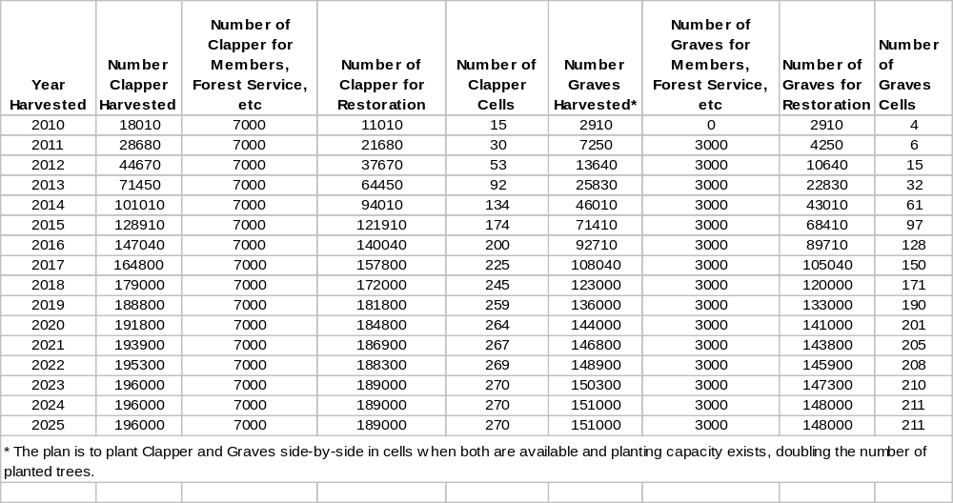

Table C—Planned Restoration Branches by State and Year

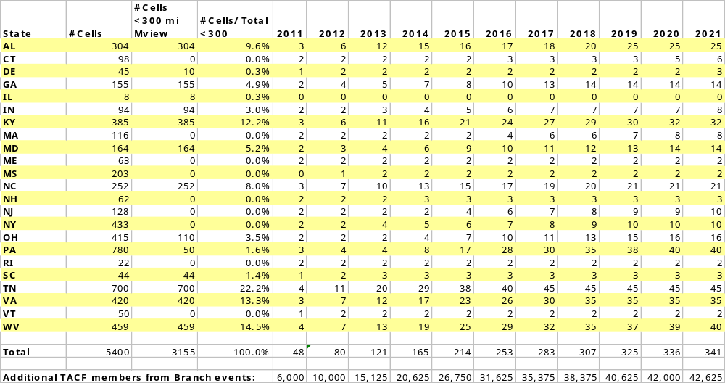

PHASE ONE RECOMMENDATIONS

Site Characteristics
Within each restoration cell, a willing landowner, private, state or federal, or NGO will be chosen.
- TACF must be allowed to grow chestnut for 30 years or more.
- Material planted and seed from these trees will remain the property of TACF.
- As a general rule, sites must have been forested, but tree-cover must be removed to 30 sq. ft. of basal area or less, prior to planting.
- Soils should be suitable for chestnut, slightly acidic, and free of Phytophthora. Ideally, chestnut sprouts grow near the sites.
- Planting sites should have reasonable road access.
- Sites should contain three acres or more and be contiguous to larger forested tracts.

Cultural Recommendations
- Plantings will be at a rate of 700 seedlings each of Clapper and Graves on three or more acres.
- Chestnuts could be planted with other species suitable for the site.
- Deer protection should be installed, if necessary
- Watering may be done during drought periods if necessary to ensure adequate survival.
- Competing vegetation should be controlled if survival of plantings is threatened.
- Fertilization may be necessary to promote rapid growth to the overstory and will be site specific.

DATA TO BE COLLECTED FOR NATIONAL DATABASE

Information on Site
- Elevation
- Aspect
- Soil type
- Detailed map of site
- Detailed directions to the site
- Contact information for the owner of the site
- Contact information for person responsible for monitoring
- Date of establishment
- GPS locations of corners of the site
- Timber type of planted site and contiguous areas.
- Site index of closely associated species

Information on Plantings –to be collected annually (initially)
- Height
- Diameter—this will begin about age 5
- Survival
- Form—use same index as testing protocols
- Severity of Cankering
- Date of bud burst
- Date of Flowering
- Date of fruit maturation
- Date of fall coloration
- Abundance of male and female flowers (0=none)
- Presence and nature of other serious insect or disease injury
- Expected dates when this would naturally occur will be established. Personnel monitoring the sites will visit on these dates to determine if the event has occurred.
An annual photo will be taken from an established photo point. Necessary lens length will be determined for the photo point.

Nomenclatures
Standardized nomenclature will be necessary for tracking seedlings and geospatial information. Each USGS quad or cell should be given a unique combination of letters and numbers that will refer researchers to the state and planting location within that cell (e.e. PA-1a, PA-2a, PA-2b would refer to Pennsylvania plantings in cell 1, the first planting in cell 2, and the second planting in cell 2, respectively).
Seedlings themselves should also have a standardized nomenclature that will let researchers determine the lineage of the planting.

MINIMUM MEASURE OF SUCCESS
Our minimum measure of success will be to have no fewer than 300 free-to-grow seedlings after five years for each source of resistance on three acres or more of planting. Replanting will be required if we have fewer than 300 before five years have elapsed.
Our objective is to grow these trees into the main canopy as quickly as we reasonably can. They should have adequate growing space for well developed crowns for nut production.

Fig. 4—Native range of American chestnut

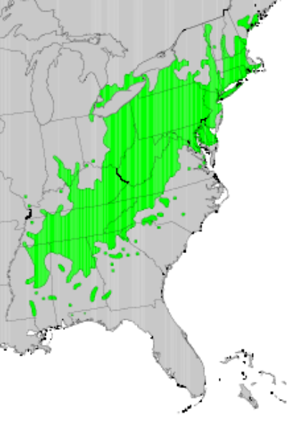
Native range of American chestnut. From Little, E.L., Jr., 1977, Atlas of United States trees, volume 4, Minor Eastern Hardwoods: U.S. Department of Agriculture Miscellaneous Publication 1342, 17 p., 230 maps.

Fig. 5—TACF’s Breeding Strategy


